Mixed Shapes
# Source: AI Source: Provided by: [Data Path: Persons Table -> ID Column: 1, Name_En Column: Motasem Essam] -> From: [ChatGPT] on [7/25/2026]
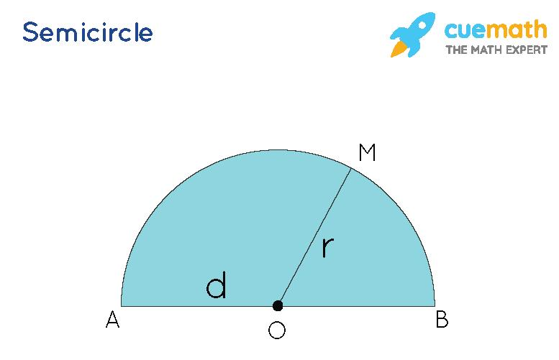
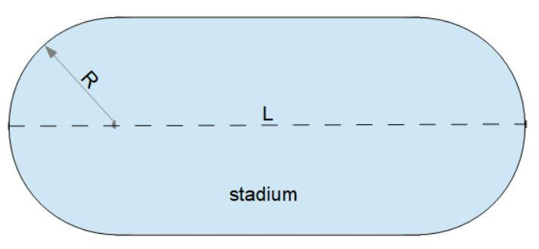
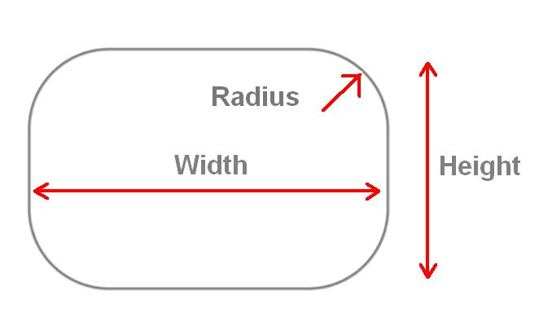
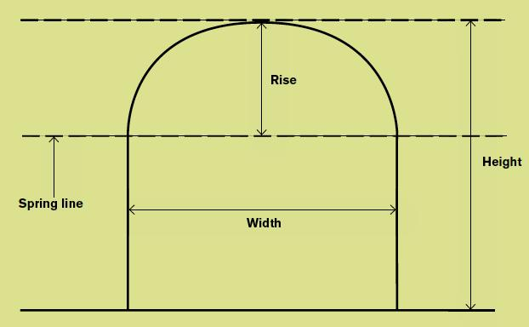
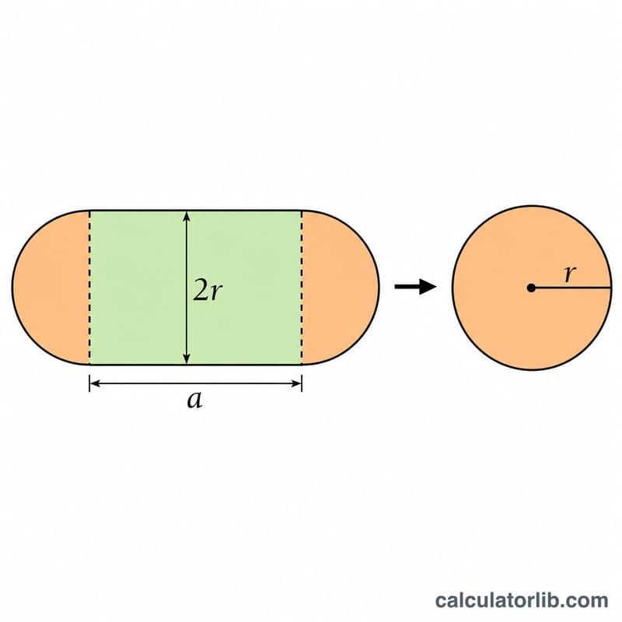
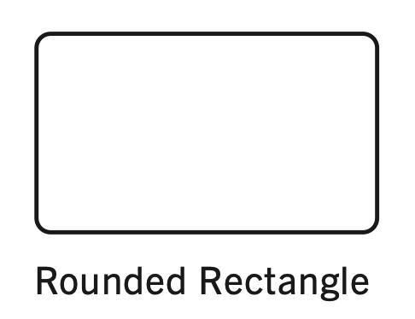
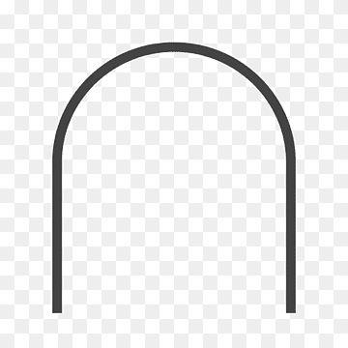

Definition
# Source: AI Source: Provided by: [Data Path: Persons Table -> ID Column: 1, Name_En Column: Motasem Essam] -> From: [ChatGPT] on [7/25/2026]
A Mixed Shape is a two-dimensional geometric figure whose boundary is composed of both straight line segments and curved sections. Unlike polygonal shapes (which have only straight sides) or curved shapes (which have only curved boundaries), mixed shapes combine both types of boundaries.
Mixed shapes are common in both mathematics and real-world design because many practical objects contain both flat and curved edges.

Characteristics
# Source: AI Source: Provided by: [Data Path: Persons Table -> ID Column: 1, Name_En Column: Motasem Essam] -> From: [ChatGPT] on [7/25/2026]
A mixed shape:
- Is two-dimensional (2D).
- Has a boundary consisting of straight and curved parts.
- May be open or closed.
- Closed mixed shapes enclose a bounded region.
- May contain vertices where straight segments meet.
- May have smooth transitions between straight and curved sections.

Mathematical Representation
# Source: AI Source: Provided by: [Data Path: Persons Table -> ID Column: 1, Name_En Column: Motasem Essam] -> From: [ChatGPT] on [7/25/2026]
A mixed shape can be viewed as the combination of:
- Straight line segments:
$$\overline{AB},\overline{BC}$$
- Curved arcs:
$$\overset{⌢}{CD}$$
Together these boundaries form one complete figure.

Common Mixed Shapes
# Source: AI Source: Provided by: [Data Path: Persons Table -> ID Column: 1, Name_En Column: Motasem Essam] -> From: [ChatGPT] on [7/25/2026]
1. Semicircle
- One curved arc.
- One straight diameter.
2. Stadium (Capsule) Shape
- Two semicircular ends.
- Two parallel straight sides.
3. Rounded Rectangle
- Four straight edges.
- Four rounded corners.
4. Arch Shape
- Curved top.
- Straight vertical sides.
5. D-Shaped Figure
- One semicircular boundary.
- One straight edge.

Properties
# Source: AI Source: Provided by: [Data Path: Persons Table -> ID Column: 1, Name_En Column: Motasem Essam] -> From: [ChatGPT] on [7/25/2026]
A mixed shape:
- Combines curved and straight boundaries.
- May have finite area if closed.
- Has a perimeter made up of straight lengths and curve lengths.
- Often models engineered or manufactured objects more accurately than purely polygonal or purely curved figures.

Real-World Examples
# Source: AI Source: Provided by: [Data Path: Persons Table -> ID Column: 1, Name_En Column: Motasem Essam] -> From: [ChatGPT] on [7/25/2026]
Mixed shapes appear in:
- Running tracks (stadium shape).
- Smartphone screens with rounded corners.
- Door arches.
- Windows with curved tops.
- Swimming pools.
- Capsules and tablets.
- Mechanical components.
- Logos and product designs.

Applications
# Source: AI Source: Provided by: [Data Path: Persons Table -> ID Column: 1, Name_En Column: Motasem Essam] -> From: [ChatGPT] on [7/25/2026]
Mixed shapes are used in:
- Plane Geometry
- Coordinate Geometry
- Engineering
- Architecture
- Industrial Design
- CAD (Computer-Aided Design)
- Computer Graphics
- Robotics
- Manufacturing
- Product Design

Advantages
# Source: AI Source: Provided by: [Data Path: Persons Table -> ID Column: 1, Name_En Column: Motasem Essam] -> From: [ChatGPT] on [7/25/2026]
Studying mixed shapes helps to:
- Model real-world objects accurately.
- Compute perimeter and enclosed area.
- Combine geometric properties of straight and curved figures.
- Design engineering and architectural structures.

Limitations
# Source: AI Source: Provided by: [Data Path: Persons Table -> ID Column: 1, Name_En Column: Motasem Essam] -> From: [ChatGPT] on [7/25/2026]
Mixed shapes:
- Often require multiple formulas to compute perimeter.
- May require calculus for exact curved lengths.
- Are generally more complex to analyze than purely polygonal shapes.

Comparison with Other Shape Types
# Source: AI Source: Provided by: [Data Path: Persons Table -> ID Column: 1, Name_En Column: Motasem Essam] -> From: [ChatGPT] on [7/25/2026]
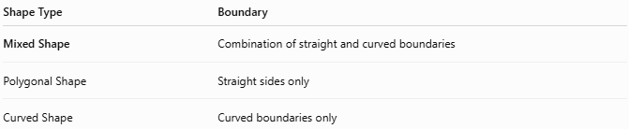
Shape Type | Boundary
Mixed Shape | Combination of straight and curved boundaries
Polygonal Shape | Straight sides only
Curved Shape | Curved boundaries only

Key Points
# Source: AI Source: Provided by: [Data Path: Persons Table -> ID Column: 1, Name_En Column: Motasem Essam] -> From: [ChatGPT] on [7/25/2026]
- A Mixed Shape combines straight and curved boundaries.
- It may be open or closed.
- Common examples include:
  - Semicircle
  - Stadium shape
  - Rounded rectangle
  - Arch
  - D-shaped figure
- Mixed shapes are widely used to model practical objects.

Conclusion
# Source: AI Source: Provided by: [Data Path: Persons Table -> ID Column: 1, Name_En Column: Motasem Essam] -> From: [ChatGPT] on [7/25/2026]
A Mixed Shape is a two-dimensional figure formed by combining straight line segments and curved boundaries into a single geometric shape. These figures bridge the gap between polygonal and purely curved shapes, making them especially useful for modeling real-world objects. Mixed shapes are fundamental in plane geometry, engineering, architecture, industrial design, CAD, computer graphics, robotics, manufacturing, and product design, where both functional and aesthetic designs frequently require combinations of straight and curved edges.

